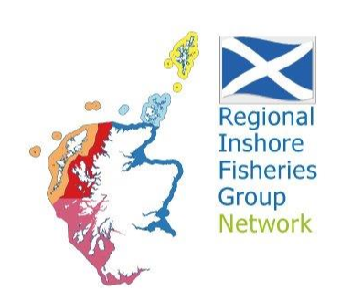

Agenda for Shetland Regional Inshore Fisheries Group Meeting to be held remotely on Teams on 17/1/24 at 12.00pm (link on email)
- Welcome, apologies, minutes and actions from the previous meeting
- Update from Marine Directorate
- Report on meeting with Gillian Martin
- Update from the SSMO
- Update from the SFA
- Issues from Shetland Fishermen
- Shetland RIFG Project update and discussion on future project options
- Shetland RIFG education projects (community talks, school visits and community use of VR technology)
- AOCB
- Date of next meeting

